L-shaped polyhedron
# Source: AI Source: Provided by: [Data Path: Persons Table -> ID Column: 1, Name_En Column: Motasem Essam] -> From: [ChatGPT] on [7/25/2026]
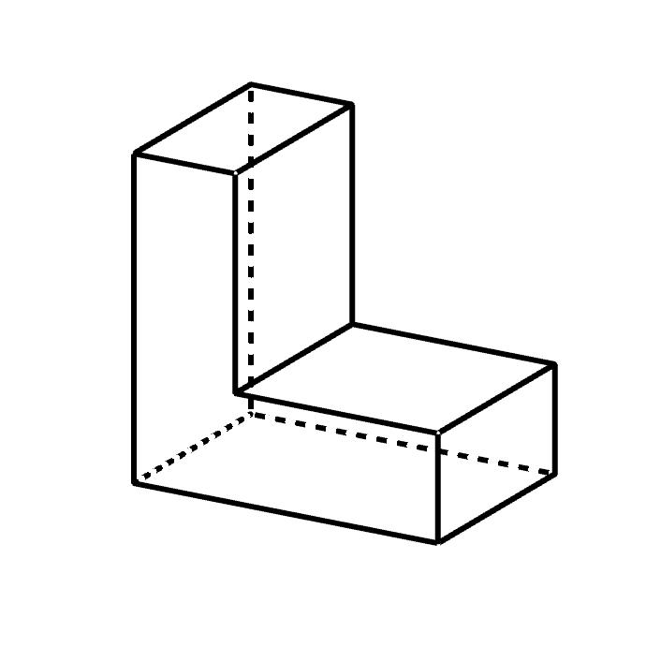
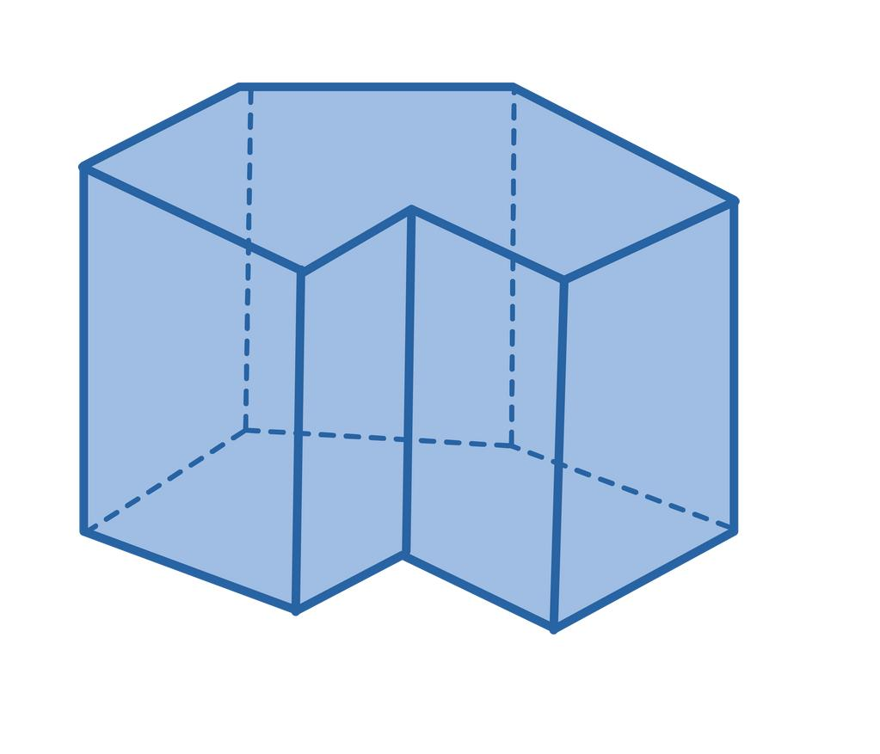
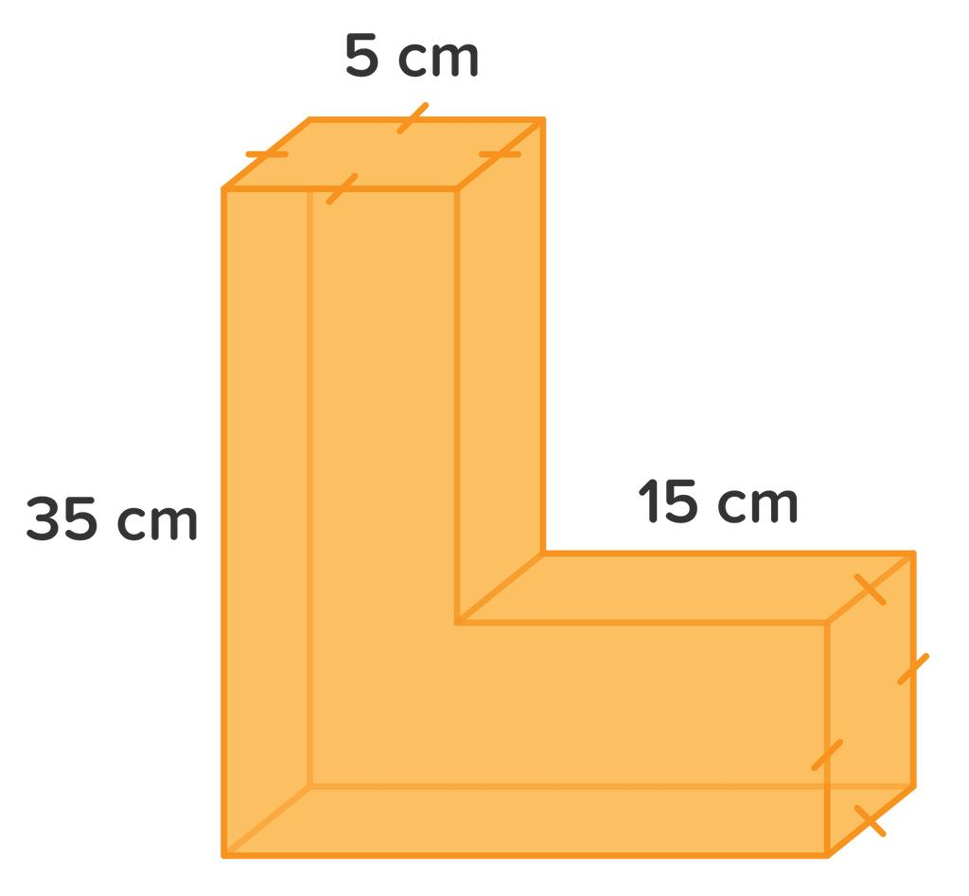

Definition
# Source: AI Source: Provided by: [Data Path: Persons Table -> ID Column: 1, Name_En Column: Motasem Essam] -> From: [ChatGPT] on [7/25/2026]
An L-shaped polyhedron is a three-dimensional polyhedron whose overall form resembles the letter L and whose boundary contains an inward corner or indentation, making the solid concave.
A common example is an L-shaped prism, formed by extending an L-shaped polygon uniformly through a third dimension. Its faces are flat polygons, and its edges are straight line segments.
The term L-shaped polyhedron describes a geometric shape rather than one unique solid. Different dimensions and constructions can produce different L-shaped polyhedra.

Simple Definition
# Source: AI Source: Provided by: [Data Path: Persons Table -> ID Column: 1, Name_En Column: Motasem Essam] -> From: [ChatGPT] on [7/25/2026]
An L-shaped polyhedron is a three-dimensional solid shaped like the letter L, with flat polygonal faces and at least one inward corner.

Key Characteristics
# Source: AI Source: Provided by: [Data Path: Persons Table -> ID Column: 1, Name_En Column: Motasem Essam] -> From: [ChatGPT] on [7/25/2026]
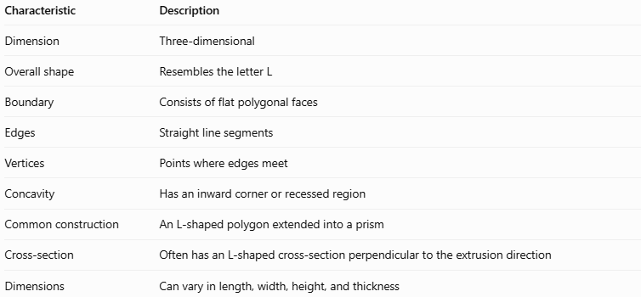
Characteristic | Description
Dimension | Three-dimensional
Overall shape | Resembles the letter L
Boundary | Consists of flat polygonal faces
Edges | Straight line segments
Vertices | Points where edges meet
Concavity | Has an inward corner or recessed region
Common construction | An L-shaped polygon extended into a prism
Cross-section | Often has an L-shaped cross-section perpendicular to the extrusion direction
Dimensions | Can vary in length, width, height, and thickness

Geometric Representation
# Source: AI Source: Provided by: [Data Path: Persons Table -> ID Column: 1, Name_En Column: Motasem Essam] -> From: [ChatGPT] on [7/25/2026]
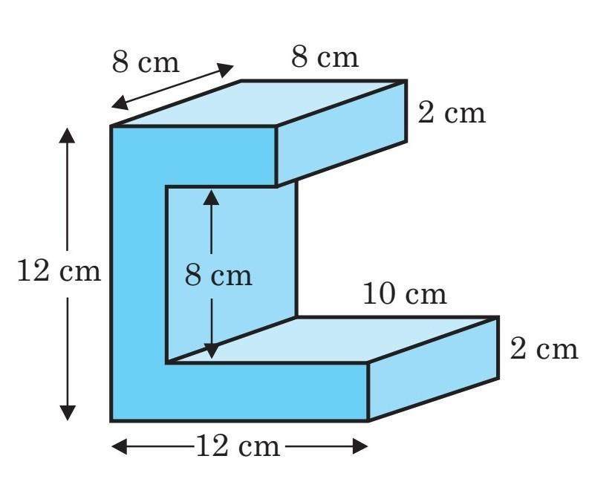
An L-shaped prism can be understood through these components:
- L-shaped base: The concave polygon forming the cross-section.
- Opposite base: An identical, parallel polygon at the other end.
- Lateral faces: Rectangular faces connecting corresponding edges of the two bases in a right prism.
- Lateral edges: Edges connecting corresponding vertices of the bases.
- Inner corner: The recessed corner responsible for the concave shape.
For the common L-shaped prism with a six-sided L-shaped base, the solid has 8 faces, 18 edges, and 12 vertices.

Mathematical Properties and Formulas
# Source: AI Source: Provided by: [Data Path: Persons Table -> ID Column: 1, Name_En Column: Motasem Essam] -> From: [ChatGPT] on [7/25/2026]
For a right L-shaped prism, let:
- $B$ = area of the L-shaped base
- $P$ = perimeter of the L-shaped base
- $h$ = length of the prism

Volume
# Source: AI Source: Provided by: [Data Path: Persons Table -> ID Column: 1, Name_En Column: Motasem Essam] -> From: [ChatGPT] on [7/25/2026]
$$V=Bh$$
If the L-shaped base is created by removing a rectangular corner from a larger rectangle:
$$B=LW-lw$$
where $L,W$ are the outer rectangle's dimensions and $l,w$ are the removed rectangle's dimensions.

Lateral Surface Area
# Source: AI Source: Provided by: [Data Path: Persons Table -> ID Column: 1, Name_En Column: Motasem Essam] -> From: [ChatGPT] on [7/25/2026]
$$A_{L}=Ph$$

Total Surface Area
# Source: AI Source: Provided by: [Data Path: Persons Table -> ID Column: 1, Name_En Column: Motasem Essam] -> From: [ChatGPT] on [7/25/2026]
$$A_{T}=2B+Ph$$

Number of Faces, Edges, and Vertices
# Source: AI Source: Provided by: [Data Path: Persons Table -> ID Column: 1, Name_En Column: Motasem Essam] -> From: [ChatGPT] on [7/25/2026]
For a prism whose base is a simple $n$-sided polygon:
$$F=n+2, E=3n, V_{e}=2n$$
For a six-sided L-shaped base:
$$F=8, E=18, V_{e}=12$$
Euler's formula verifies the counts:
$$V_{e}-E+F=12-18+8=2$$
These counts apply to the common L-shaped prism, not every possible solid that resembles an L.

Worked Examples
# Source: AI Source: Provided by: [Data Path: Persons Table -> ID Column: 1, Name_En Column: Motasem Essam] -> From: [ChatGPT] on [7/25/2026]
Example 1: Calculating the Volume
An L-shaped prism has a base formed by a $6\text{ cm}×5\text{ cm}$ rectangle with a $3\text{ cm}×2\text{ cm}$ rectangular corner removed. The prism has a length of $4\text{ cm}$.
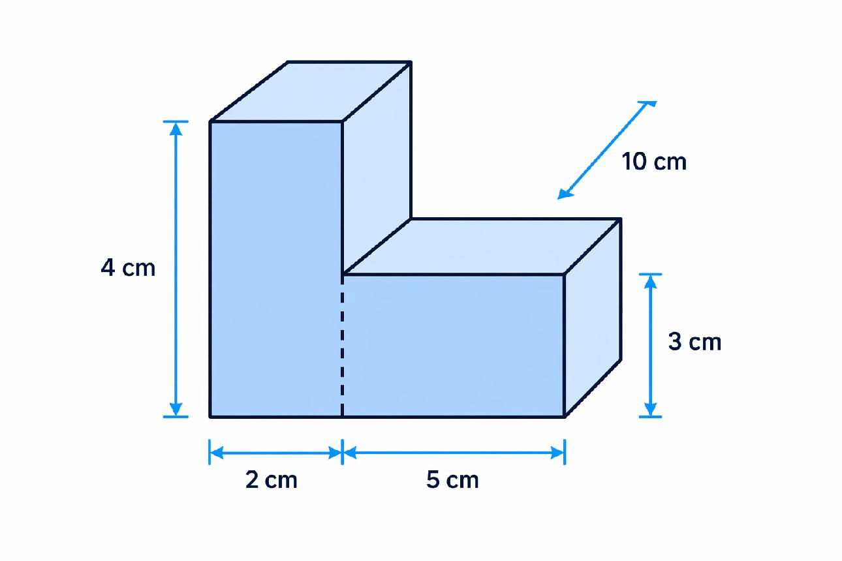
Step 1 — Calculate the base area.
$$B=\left(6×5\right)-\left(3×2\right)$$
$$B=30-6=24{\text{ cm}}^{2}$$
Step 2 — Calculate the volume.
$$V=Bh=24×4$$
$$\boxed{V=96{\text{ cm}}^{3}}$$
Example 2: Calculating the Total Surface Area
Using the same prism, the L-shaped base has a perimeter of $22\text{ cm}$.
Step 1 — Calculate the lateral surface area.
$$A_{L}=Ph=22×4=88{\text{ cm}}^{2}$$
Step 2 — Calculate the total surface area.
$$A_{T}=2B+Ph$$
$$A_{T}=2\left(24\right)+88$$
$$\boxed{A_{T}=136{\text{ cm}}^{2}}$$

Comparison with Related Concepts
# Source: AI Source: Provided by: [Data Path: Persons Table -> ID Column: 1, Name_En Column: Motasem Essam] -> From: [ChatGPT] on [7/25/2026]
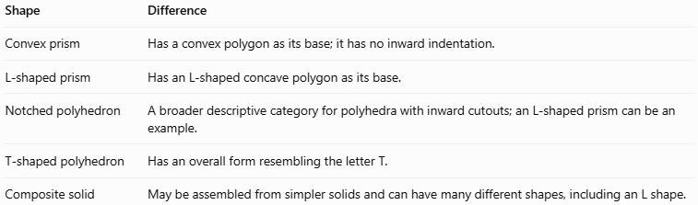
Shape | Difference
Convex prism | Has a convex polygon as its base; it has no inward indentation.
L-shaped prism | Has an L-shaped concave polygon as its base.
Notched polyhedron | A broader descriptive category for polyhedra with inward cutouts; an L-shaped prism can be an example.
T-shaped polyhedron | Has an overall form resembling the letter T.
Composite solid | May be assembled from simpler solids and can have many different shapes, including an L shape.

Constructing L-shaped polyhedron in Solid Geometry

Instruments Used
# Source: AI Source: Provided by: [Data Path: Persons Table -> ID Column: 1, Name_En Column: Motasem Essam] -> From: [ChatGPT] on [7/25/2026]
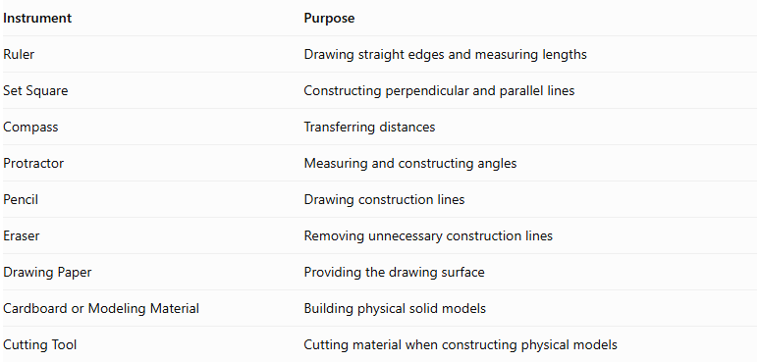
Instrument | Purpose
Ruler | Drawing straight edges and measuring lengths
Set Square | Constructing perpendicular and parallel lines
Compass | Transferring distances
Protractor | Measuring and constructing angles
Pencil | Drawing construction lines
Eraser | Removing unnecessary construction lines
Drawing Paper | Providing the drawing surface
Cardboard or Modeling Material | Building physical solid models
Cutting Tool | Cutting material when constructing physical models

Construction Procedures

A. Addition-Based Construction
# Source: AI Source: Provided by: [Data Path: Persons Table -> ID Column: 1, Name_En Column: Motasem Essam] -> From: [ChatGPT] on [7/25/2026]
This method forms an L-shaped polyhedron by joining two rectangular prisms.
- Determine the dimensions of the two rectangular prisms.
- Draw the first rectangular prism using an appropriate pictorial representation.
- Draw the second rectangular prism perpendicular to the first.
- Position the two components so that they share a complete rectangular face or an appropriate connecting region.
- Join the two components to form an L-shaped solid.
- Remove or suppress internal boundaries that are not part of the external surface.
- Draw the visible external and recessed faces.
- Distinguish visible edges from hidden edges.
- Check that the resulting solid has a continuous closed surface.

B. Subtraction-Based Construction
# Source: AI Source: Provided by: [Data Path: Persons Table -> ID Column: 1, Name_En Column: Motasem Essam] -> From: [ChatGPT] on [7/25/2026]
This method creates an L-shaped polyhedron by removing a rectangular portion from a larger rectangular prism.
- Draw a rectangular prism.
- Identify the rectangular region to be removed.
- Mark the boundaries of the removed portion.
- Construct the cutting boundaries on the relevant faces.
- Remove or visually suppress the selected rectangular portion.
- Draw the newly exposed inner faces.
- Connect all remaining face boundaries.
- Refine the visible and hidden edges.
- Check that the resulting solid has an L-shaped appearance.

C. Cross-Section-Based Construction
# Source: AI Source: Provided by: [Data Path: Persons Table -> ID Column: 1, Name_En Column: Motasem Essam] -> From: [ChatGPT] on [7/25/2026]
- Draw an L-shaped polygon representing the cross-section.
- Mark the lengths of its horizontal and vertical arms.
- Draw a second congruent L-shaped polygon at the required depth.
- Connect corresponding vertices of the two polygons.
- Complete the rectangular lateral faces.
- Darken the visible edges and distinguish hidden edges.

D. Face-Based Construction
# Source: AI Source: Provided by: [Data Path: Persons Table -> ID Column: 1, Name_En Column: Motasem Essam] -> From: [ChatGPT] on [7/25/2026]
- Identify the external rectangular faces and the recessed faces.
- Draw the main horizontal and vertical surfaces.
- Construct the inner corner surfaces.
- Connect the adjacent faces using shared edges.
- Complete the external boundaries of the solid.
- Check that all faces form a closed polyhedron.

E. Net-Based Construction
# Source: AI Source: Provided by: [Data Path: Persons Table -> ID Column: 1, Name_En Column: Motasem Essam] -> From: [ChatGPT] on [7/25/2026]
- Determine the number and dimensions of all external and recessed faces.
- Draw a connected net containing the two L-shaped end faces and the rectangular lateral faces.
- Arrange the faces so their shared edges correspond correctly.
- Add tabs if the net will be used for physical assembly.
- Cut out the net.
- Fold along the shared edges.
- Join the corresponding edges to form the L-shaped polyhedron.
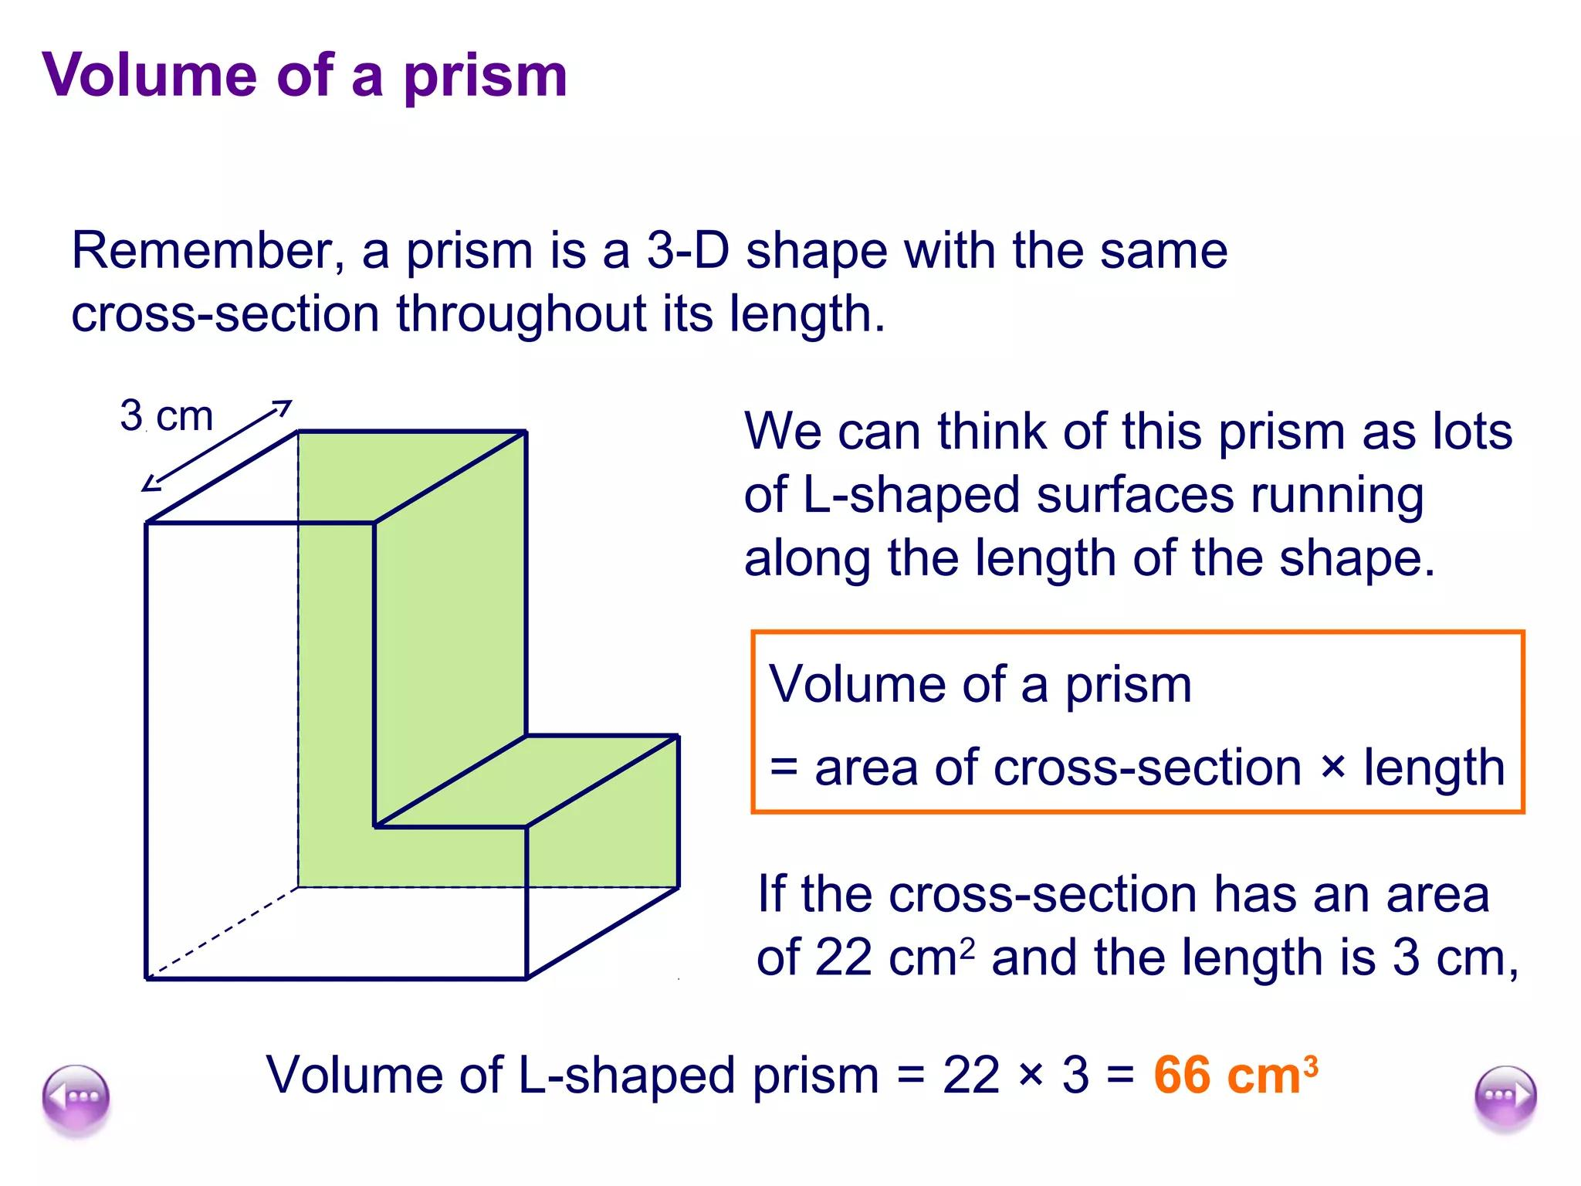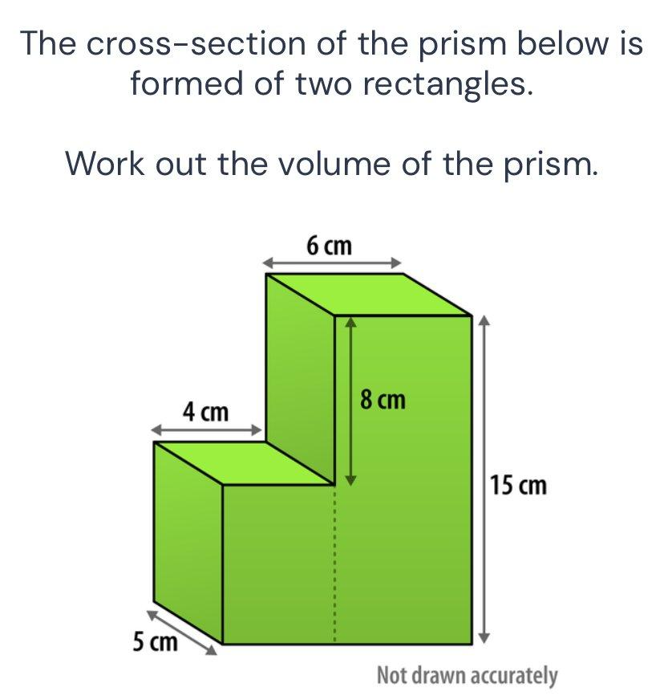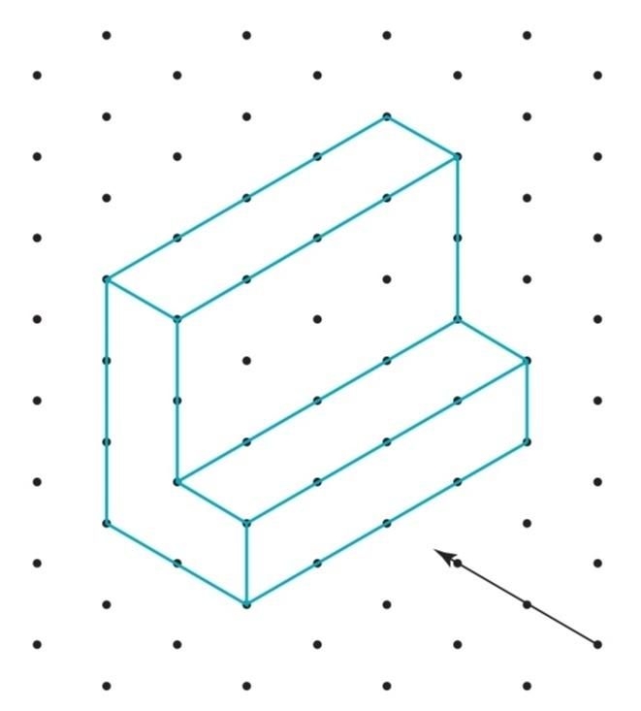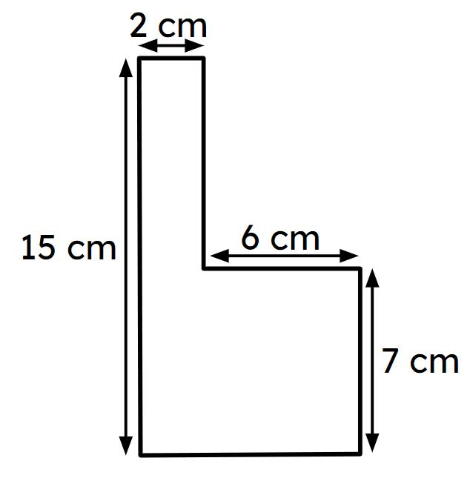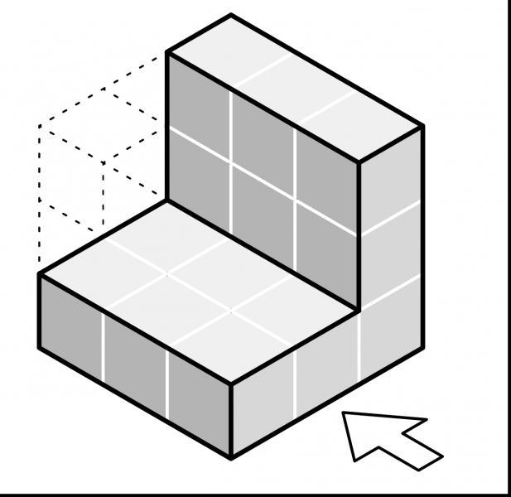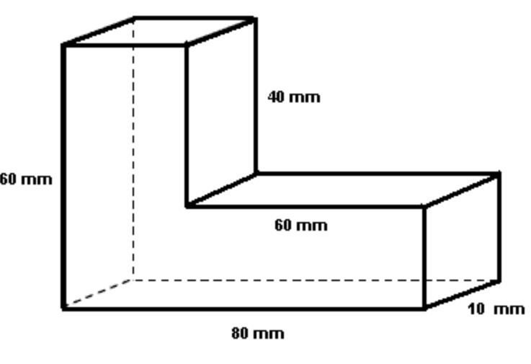

Applications
# Source: AI Source: Provided by: [Data Path: Persons Table -> ID Column: 1, Name_En Column: Motasem Essam] -> From: [ChatGPT] on [7/25/2026]
- Architecture: Modeling L-shaped buildings and floor plans.
- Construction: Calculating the volume of L-shaped concrete sections.
- Engineering: Designing brackets, supports, and structural components.
- Manufacturing: Representing parts with an L-shaped cross-section.
- Computer graphics: Modeling concave objects using polygonal surfaces.
- Mathematics education: Practicing area, perimeter, volume, and surface-area calculations.

Key Points
# Source: AI Source: Provided by: [Data Path: Persons Table -> ID Column: 1, Name_En Column: Motasem Essam] -> From: [ChatGPT] on [7/25/2026]
- An L-shaped polyhedron is a three-dimensional solid that resembles the letter L.
- The common example is an L-shaped prism with a concave polygonal base.
- A typical L-shaped base has six sides.
- A right prism with a six-sided base has 8 faces, 18 edges, and 12 vertices.
- Its volume is the base area multiplied by the prism length.
- Its total surface area is $2B+Ph$ when it is a right prism.
- An L-shaped polyhedron is a specific shape description within the broader family of concave polyhedra.

Conclusion
# Source: AI Source: Provided by: [Data Path: Persons Table -> ID Column: 1, Name_En Column: Motasem Essam] -> From: [ChatGPT] on [7/25/2026]
An L-shaped polyhedron is a concave three-dimensional solid distinguished by its L-like overall form and inward corner. The L-shaped prism is its most familiar example, allowing volume and surface area to be calculated using the base's area and perimeter. This shape is useful in geometry, architecture, construction, and engineering.

